

**THE UNIVERSITY OF AZAD JAMMU KASHMIR MUZAFFARABAD**

**LAB TASK NO# 1**

**OPERATING SYSTEM**

**DEPARTMENT OF SOFTWARE ENGINEERING**

**SUBMITTED TO:** Engr. Sidra Rafiq

**SUBMITTED BY:** Asif Ullah

**SUBMITED ON:** 13/11/2024

**SEMESTER:** 3rd

**COURSE CODE:**

**ROLL NO# BS-2023-SE-38**

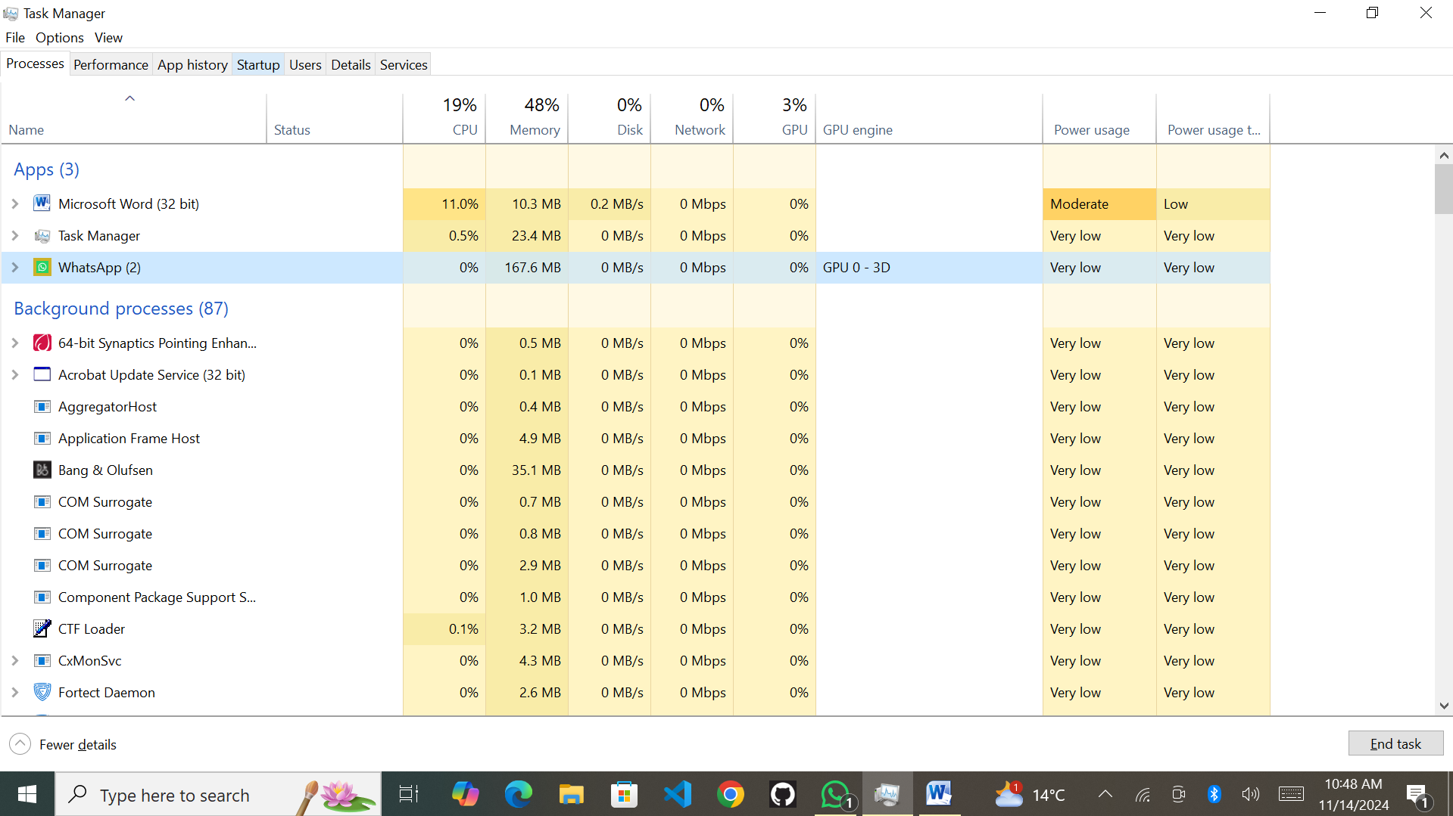**Task Manager:**

**Services:**

